OTBETbI

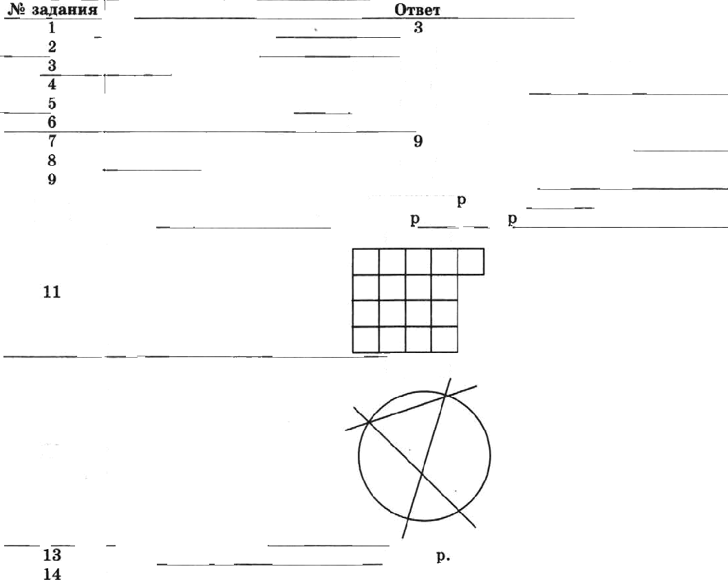
Bapoanx 1
 | 14,6
 | 16,8
 | 1,28; 1,208; 1,03
 | 2,25
10.1 | vH£8HT008B
10. 2 | riipanaoaaa u cTeroaaa
 | Hpiiuep
12 | MpnMep
 | 180 cz
 | 6 oenoae«
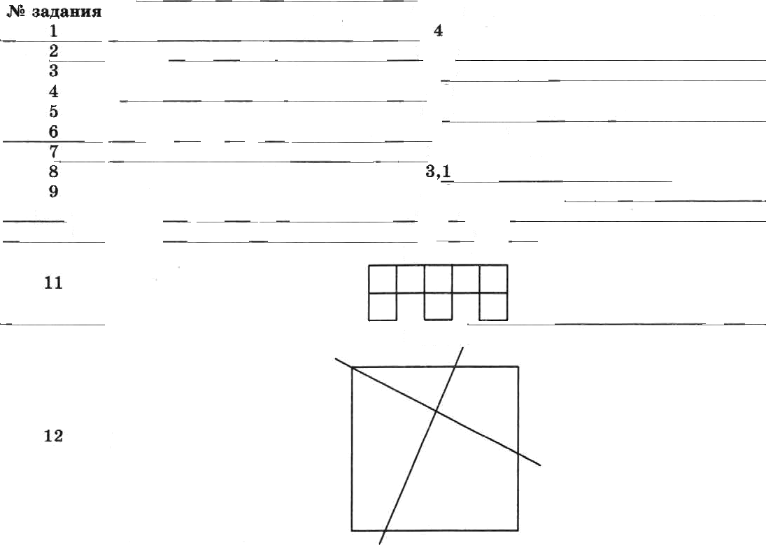
Baprianx 2
 | Orsex
 | bBA
 | 32,6
 | 1.8
 | 816
 | 5.072:572; 18
 | IT
 | 108
10.2 | BezysnZ
 | Ilpxmep
 | Mpnvep
13 | ]80 xr
14 | ] sezozex

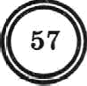
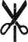
57

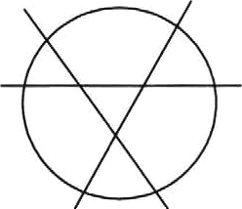
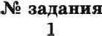
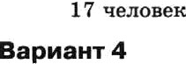
Bap›sanx 3
 | Ozser
 | 2
2 | BEA
4 | 07
5 | 18',2
6 | 4,9; 4,85; 4,805
 | 10
8 | 1,53
10.1
10.1 | OxONO 250 na
11 | Ilpusep
12 | ITpnuep
14

1 | 5
 | BAb
 | 57,7
4 | 5,3
5 | 12,9
6 | 8,027; 8.2; 8,2T
7 | 20
 | 120
10.2 | momsAa x meAreAa
11 | Mpaxep  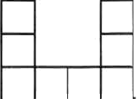
11 | Mpamep
 | 21 «
 | 8 veaoee«

Bapxa++x 5
2
4t.6
8,4

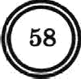

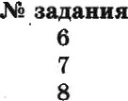

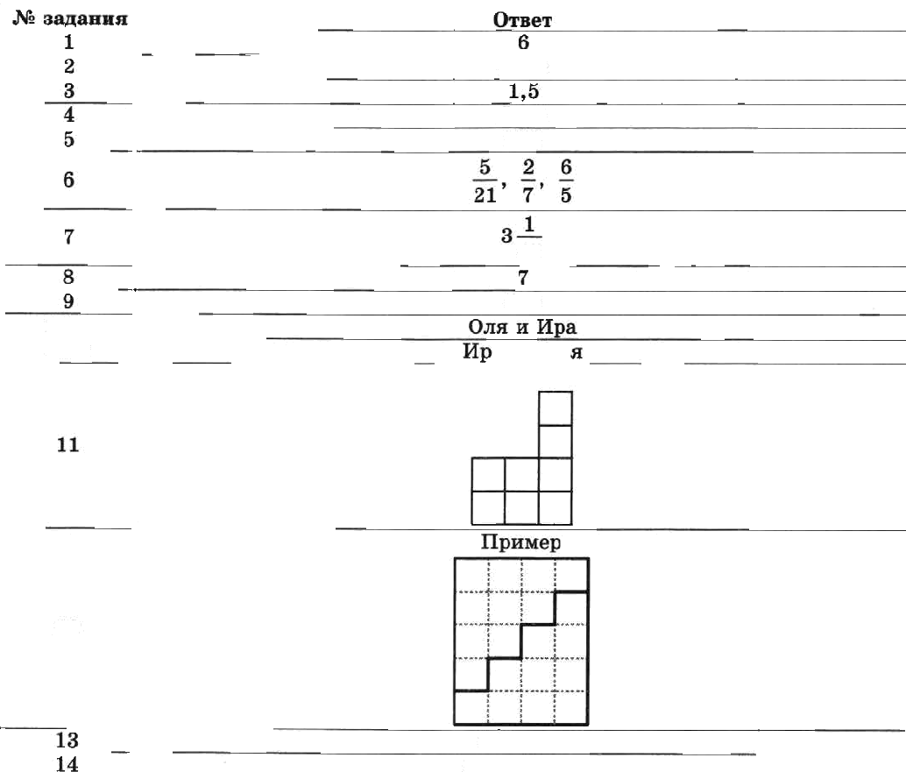
Bapøa+ız 6
 | Òreex
 | 6,5; 6,35; 6,305
 | 24
 | 2,24
 | 90
10.1 | 5
10.2 | Oxozol9oxm’
 | Mpxxep
 | Mpaxep
 | 27caos
14 | 15 xexouez

 | ADB
 | T8,6
 | 306
 | 45
 | 525
10.1
10.2 | ø x Eon
 | Mpmxep
12
 | ł4oAeı.
 | 8ł ueaosen

Baplaanz 7
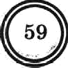
 | Oıøeı
1 | 8
2
 | 5,T
4 | 2,94
5 | 1148

