ycTHAfi HACTb
71

BapnaHv 7

Task 1. You are going to read the text aloud. You have 1.5 minutes to read the text silently, and then be ready to read it aloud. Remember that you will not have more than 2 minutes for reading
aloud.
Scientists believe that the horse first appeared in North America. But it was not the horse we know today. It was a fox-sized animal only about a foot high at the shoulder. Man established a relationship with the horse about 50,000 years ago. At first people hunted horses, which wasn’t very easy, then they learned to herd these animals, and kept them mainly for meat, possibly also for milk, but it is likely that the horses were also used to carry things when people had to move from one place to another. The horse was becoming a worker — a source of help to man — not just a meal on the hoof. Most scientists think that the first horses were used to pull carts, not for riding. But people finally mounted the horse. And suddenly they could travel long distances and explore unknown lands. People quickly realized how useful the horse could be.

Task 2. You are going to take part in a telephone survey. You have to answer six questions. Give
full answers to the questions. Remember that you have 40 seconds to answer each question.

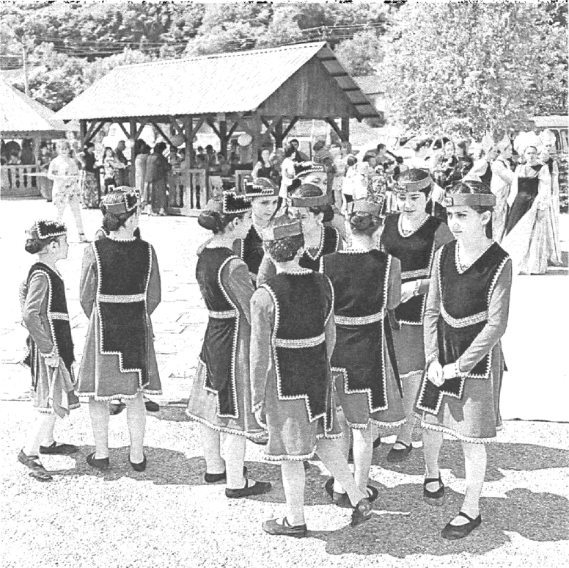
Task 3. You are going to give a talk about clothes you prefer to wear on different occasions. You will have to start in 1.5 minutes and speak for not more than 2 minutes.
Remember to say:
- what you usually wear at school;
- who advises you what to wear;
- what styles of clothes you prefer for everyday life, parties.
You have to talk continuously.

