ycTHAfi PACTb

BapnaHv 3

Task 1. You are going to read the text aloud. You have 1.5 minutes to read the text silently, and then be ready to read it aloud. Remember that you will not have more than 2 minutes for reading
aloud.
Physical fitness is a general state of good health, usually as a result of exercise and nutrition. Physical fitness can also be described as a condition that allows us to look, feel and do our best. Being fit helps us have more energy for work or school throughout the day, and enough energy to enjoy our leisure time activities. Fitness is an individual quality. It is influenced by age, sex, heredity, personal habits, exercise and eating practices. You can’t do anything about the first three factors. However, it is within your power to change and improve the others where needed. The level of physical fitness can be influenced by regular, systematic exercise. How often, how long and how hard you exercise, and what kinds of exercises you do should be determined by what you are trying to get. For example, an athlete training for high-level competition would follow a different program than a person whose goals are good health and active like.

Task 2. You are going to take part in a telephone survey. You have to answer six questions. Give full answers to the questions. Remember that you have 40 seconds to answer each question.

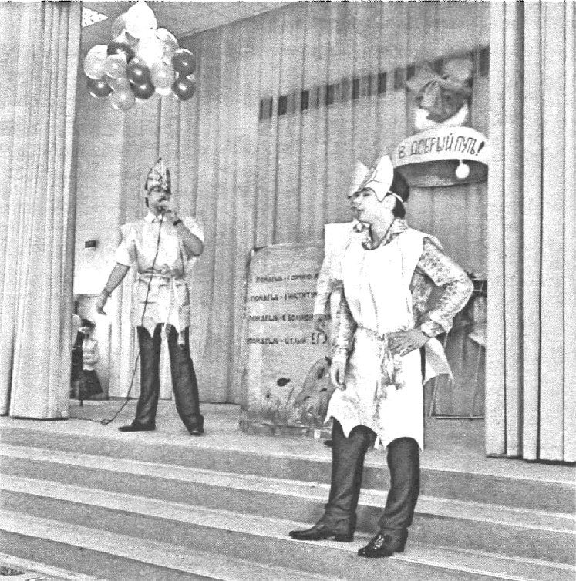
Task 3. You are going to give a talk about your school life. You will have to start in 1.5 minutes and speak for not more than 2 minutes.
Remember to say:
- if your school life is interesting/boring;
- what school activities you take part in;
- what school events you remember best of all and why.

You have to talk continuously.

