mors ozpaHcxp nu u zexczoø grin ayqopoBaHHii LISTENING (no 2 6anna 3a xa stii BepHsiii ozBe+)

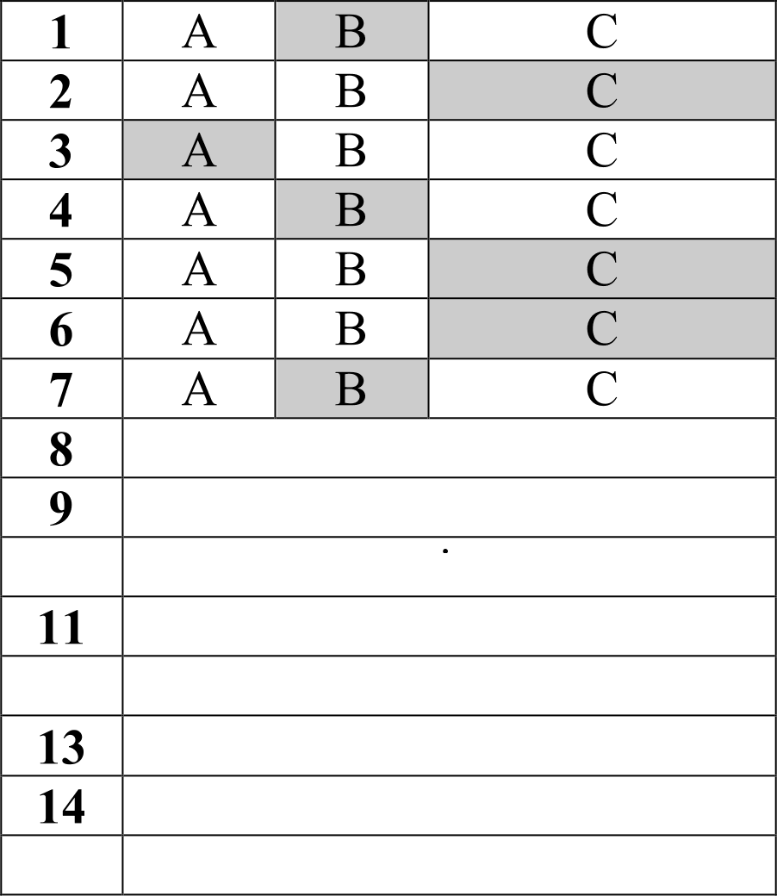
aunt, too nervous hired car
10 tie
watching quiz shows
12 the green room university teacher general knowledge
15 (big) television / TV

READING (no 1 6anny 3a xamosiii Bep sIii ozBez)
1 | up
2 | of
3 | the
4 | ok
5 | by
6 | ok
7 | ok
8 | ok
9 | ok
10 | ok
11 | to
12 | to
13 | just
14 | ok
15 | still
16 | D
17 | G
18 | B
19 | J
20 | H
21 | E
22 | A

23 | F
24 | C
25 | I.

USE OF ENGLISH (no 1 6anny 3a xamosiii BepHsiii ozBez)

1 | chat away
2 | eat away at
3 | hand out
4 | lie around
5 | mess around
6 | run off
7 | shout out
8 | speak out
9 | see off
10 | slow down
11 | take down
12 | work out
13 | run off
14 | eat away at
15 | take down
16 | (break) even
17 | (dream your) life away
18 | (go) bust
19 | (be in the hot) seat
20 | (be in the) red / headlines
21 | (make) headlines
22 | ((be) over) the moon
23 | (score) a hat-trick
24 | (strike) it rich
25 | (try) your hand at something
26 | dreaming his life away
27 | over the moon
28 | scored a hat-trick
29 | made headlines
30 | try his hand at
31 | breaking even
32 | went bust
33 | in the hot seat
34 | in the red
35 | struck it rich

SCRIPT

Task 1

LISTENING

Good evening and walcorna to the prggrammg. This eyenirigs guest is headmaster of East Crompton Comprehensive Dr. Charles Greenway, and we’re gaiaq to be talking about truancy. Dr. Greénvv&/, tflaftk8 fof johir1g me this eyeqing, Good evening. J’in pleased to be here.
Let’s begin by defining the word truancy. What do we actually mean a auple of mixed £eAhS, a weeL's hdaJby dudng turn rime or mpmwd agent fmm tool with ng expb wn 7
tel a good question to begin vvirh, PauI. Any ab ence rkat has not been authorised by' tile schoo| i5 truancy. It doesn't matter if a cftild is being taken to Disn@and n Florida because it's Cheaper in term time, gainq Chri5tma shopping yviLh a pareFt, or just roaming around the neighbourhood v‹nth orher children causing problems for the loCal residents. It’s all truancy.
HQvr widesprea‹f is the problem in the °Jnited Kingdom?
Very, I’m afraid. As many as fcxJr million school day ae last y year through vuancy, and about 1.7 mili@n of those are IosL because of children being taken on family hdidays and axcursJons. Trol agents h‹ve 4pecél coffee during term time, s› its a lot Ehaapar fgr a family to go away. This goveff1melt wg/ s to raise educational standards, but we can't do that if children miss school. Full atterx:lance i a precondittcn /cr effective learning.
Did I heir c0rreclJ}' just then - alrtx4L half the days k›st because of nJancy are because of parents taking their ‹hildren on holiday? Yes. exactly. It is quite shocking. im't its Imagine how incre.dibly diffimlt ie is for us t0 cgnvinoe chiIdren that missing schocif for no guod reason is a bad thing when I heir own parents behaw in s'JCh an iTr0:ponsibie manner.

It must be. What are \l›a government doing in. vow of his
situation ?
WeI|, afb leafs of campaigning oy taad ers all over the auntry,
I:he gove‹nmerc are Finally beginning to unde mnd that sQmethinq has to @ dQne. They fe $u[03mJy folaing talks with the travel industry to encourage travel agents to gave di nts to families \v 0 Lc›Ok thnr cips in the scowl holidays, and the police are now invok/ed in pici•»g up chibren on the streets, Sooa| workers are also being recruited to work with the families or I:hiIdren who pI6g tMarTt. Anrt UI Our part wa're patting up
behaviour ‹mp+ovemeM p'0 in +h• PJfccJ teach children d@ipline and respect for teaming, eut let mg run Again thai
mosc oF the re• nsibilfty for ensuring tt1at a child is af school lies with tone paren IS NeglKLi£ig tf+1s r porsibiIi1:y is a criminal offence.

their children do not attend lessons?
That's exactly what 1 mean, although this law s p‹x›rIy enfoxed. It should, ir my Opiniqn, ba better enforced. The future at ‹:nr children matters. We owe it to them to give tken the bast education possible, and we Attn only do tha or they are in school.
I agree with what you' a saying, but don't you think 'I’d a li ltte harsh to prosecute parenD of truant Children ?
It may seem sa to the average Per$on. has. but I ouO like to stress again that the Mture of this country i5 the Schoolchildren of today. It is impossible for the Schools to prepare thin for life if the children are not a scL¢o1, and parents Simply must be on pUr Side when it comes tc› stopping children playing trua nt.

I see your point. I think it’s about the right time to take a few czlb from oui listeners. we've got William Peterson on the line. G‹:md morning, Mr. f'eterson?

Task 2

