Writing
Time: 1 hour 15 minutes

Imagine that you are doing a project on how students in the USA spend their time on an average weekday. You have collected some data on the subject (see the charts below). Write a brief report describing the data. Try to use all the information given and compare the data for 2014 and 2015.

Use the following words in your report (put them in the correct grammar
form if necessary):
- assess
- extracurricular
- catch on
- pursuit
- substitute

Underline the required words when used in your report.

Write 220—250 words.
Use the following plan:
- make an opening statement
- give some general information and outline most significant trends
- compare the information given in the charts
- make a conclusion

USE YOUR OWN WORDS AND EXPRESSIONS in your report.

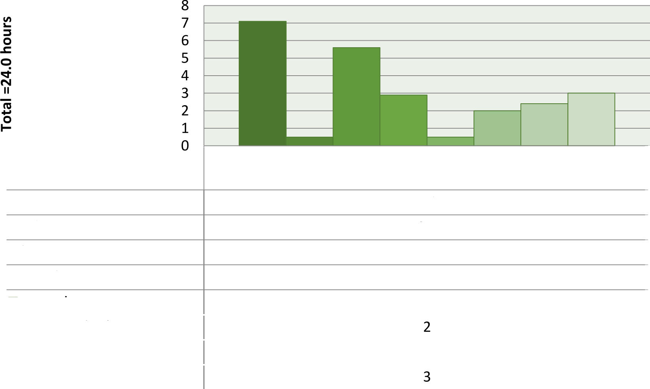

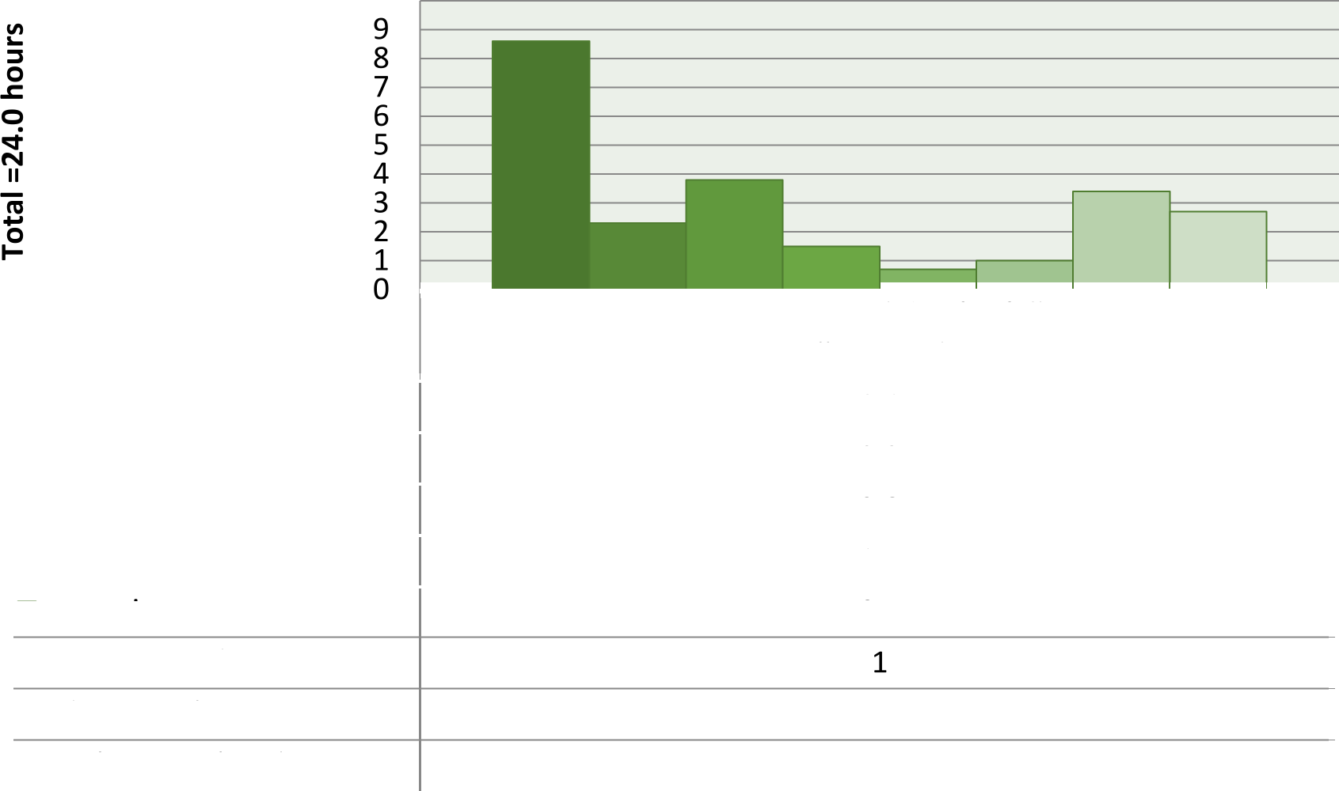
10

 | Time use on an average weekday for full-time university & college students
- sleeping | 8,6
- other | 2,3
- leisure & sports | 3,8
- traveling | 1,5
O grooming | 0,7
O eating & drinking
O educational activities | 3,4
O working & related activities | 2,7

 | Time use on an average weekday for full-time university & college students
- sleeping | 7,1
- other | 0,5
- leisure & sports | 5,6
- traveling | 2,9
O grooming | 0,5
O eating & drinking
O educational activities | 2,4
O working & related activities

