Use of English
Time: 60 minutes

Task 1
For items 1-5, read the text below and think of the word which best fits each gap. Write down the needed word in your answer sheet. The first example (0) is done for you.

Hard Work of Rescue Teams
Example: (0). by

Last year over 200 climbers were rescued from the mountains of Scotland alone
(0) .. . local rescue teams who go out in all weathers to do whatever they can to help when disaster strikes. These people are volunteers, giving their time and energy freely and, (1) ... occasion, putting themselves in danger. They risk life and limb in an emergency when they are called on to rescue foolhardy or unlucky climbers.
A whole range of things can go wrong up in the mountains. A storm can brew up without warning, reducing visibility (2) ... virtually zero. Then only the most experienced mountaineers could find their way back down to safety. And it is easy to
(3) ... to grief, breaking a leg — or worse. Many climbers owe a huge debt of gratitude to the rescue teams!
While rescue teams work for no pay, there are considerable costs involved in maintaining an efficient service. Equipment such as ropes and stretchers (4) ... of some vital importance, as are vehicles and radio communications devices. Though some of the costs are borne by the government, the rescue teams couldn't operate without donations from the public. Fortunately, fund-raising for a good cause like this is not difficult; anyone who has ever been up in the mountains will gladly (5) ... a contribution.
Task 2
For items 6 — 10, complete the second sentence so that it has a similar meaning to
the first sentence, using the word given. DO NOT CHANGE the word given. You

should use between three and six words, including the word given. Write down the needed words in your answer sheet. The first example (0) is done for you.
Example: 0. I consider him my worst enemy.

LOOK
I............................................................................................ enemy.
- I look upon him as my worst enemy.

  - Even if we drive very fast, we'll never get to the theater on time. HOW
No ................................................., we'll never get to the theater on time.

  - At no time did we think that Mike might be planning to leave London. OCCURRED
It ..............................................that Mike might be planning to leave London.

  - Paula had just reached the gate when it began to rain. THAN
No sooner .................................................................................it began to rain.

  - He behaved in an incomprehensible way at the party. BEYOND
His .....................................................................................our comprehension.

  - You may not have noticed but Sam is wearing an engagement ring. ESCAPED
It ...............................................notice but Sam is wearing an engagement ring.

Task 3
For items 11-15, filI in the crossword by working out the meanings of the phrasal verbs in the clues. Underlined phrasal verbs require synonyms. Write down the required synonyms in your answer sheet. The first example (0) is done for you.

Example: 0. (across) Why do you always let me down by arriving so late?
0. disappoint

  - (down) The guarantee is due to run out next week.
  - (down) I hope my words do not put you off.
  - (across) The coach doesn't get into Victoria until 6 p.m.
  - (down) It isn't possible to take in all these phrasal verbs.
  - (across) The waving of a white flag can signify that one side in a battle is prepared to give up.

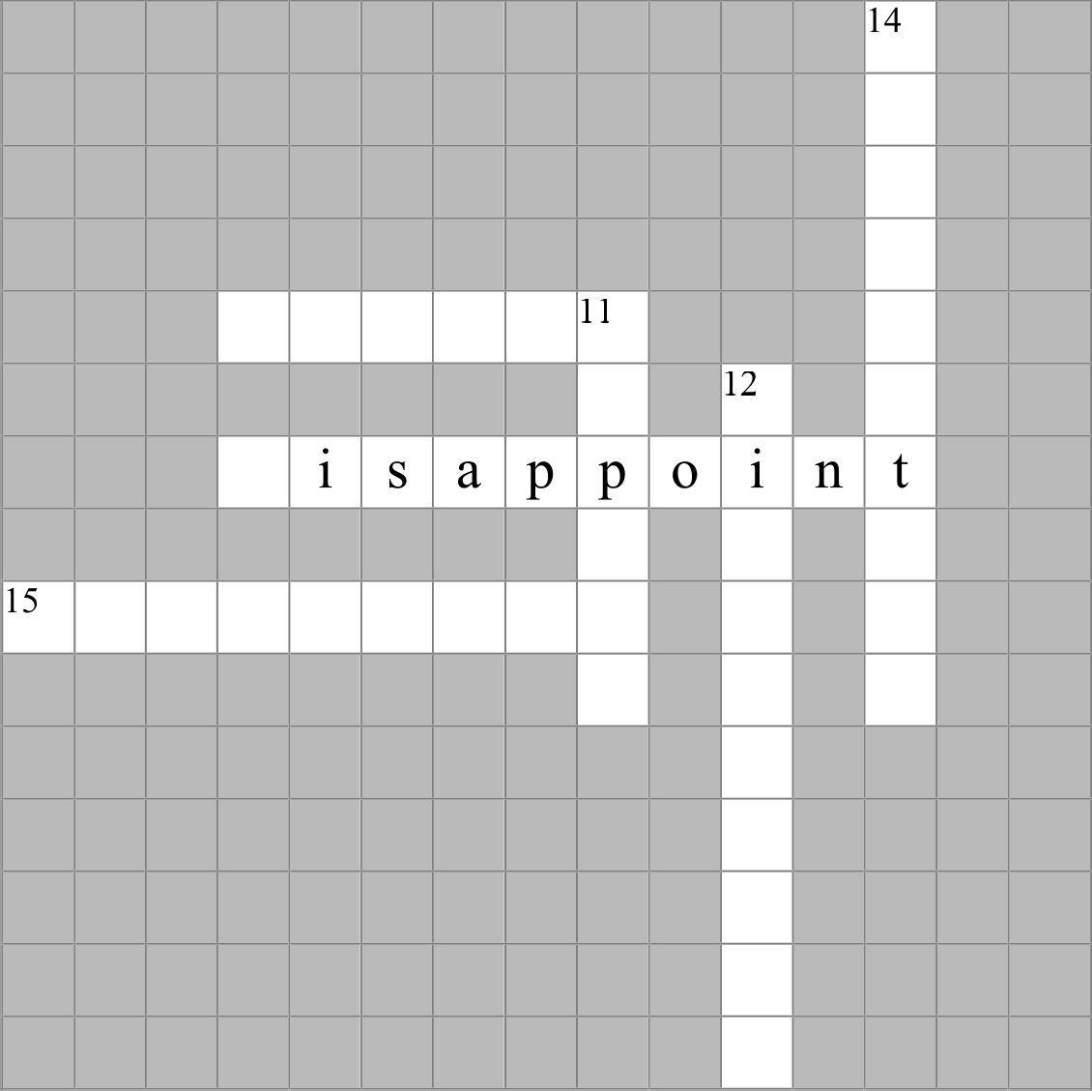
13

0 d

Task 4
For items 16-20, choose from the box the necessary animal (1-13) that would fit in the gap of the given sentences (16-20) to produce a proverb or an idiom, then match the sentence with the correct definition (A - F). There are some extra words in the box, which you do not have to use. The first example (0) is done for you.

Example: 0. It's raining ... and....
0. 2, 6 E
I-cat, 2-cats, 3-cow, 4-dog, 5-dogs, 6-does. 7-goats, 8-horse, 9-lion, 10-mice, 11-
rabbit, 12-sheep, 13-tiger

  - When the ....'s away the .... will play.

  - That's a ... of a different colour.

  - Better to be a live ... than a dead ...

  - To separate the ... from the

  - To go to the

Definitions:
- a situation or a subject far from what you expected

- there are some situations when being a coward is an advantage

- when a person in authority is absent, those under the person's rule will enjoy their freedom

- to deteriorate, to become bad

- something that you say when it is raining very heavily

- to group people or things into superior and inferior

Task 5
For items 21-30, identify the names of an English or an American city/town, hidden in the sentences below. Write down the correct names in your answer sheet. The first example (0) is done for you.

Example: 0. After competing in a triathonlDonna was very tired. (the capital of the UK)

0. London

  - The bank won't be able to issue a new credit card if for some reason
you forget your PIN, so be extra careful. (the capital of Wales)

  - The pilot had to decide whether to initiate a go-around or land on the ground in inclement weather. (a city in the U.S. state of Florida, Walt Disney World Resort, also the name of a famous Hollywood star, whose surname is Bloom)

  - The gingerbread ingredients are on the table. I will help you to make it. (the names of two cities, situated in the UK and the USA, and a homograph to an activity connected with books)

  - Housekeepers usually prefer washing to not doing anything. (the name of a city that is associated with the first name of a famous American writer and the surname of an American president)

  - The local Congressman Chester Charing spoke about the environmental problems of the region. (people who live in this city are called Mancunians)

  - A person who wants to purchase a car usually either buys it brand new or leans towards getting a used one. (a major United States port on the Mississippi river, known also as the birthplace ofjazz)

  - Please, use the suggestion box for direct comments about the quality of
the food in our restaurant. (a city where Lewis Carroll lived and worked)

  - The sacrament of marriage is one of the key rituals of the Catholic
Church. (the capital of California)

  - Mabel fastened her seat belt before the plane took off. (the capital of Northern Ireland)

  - As one considers history, it becomes quite apparent that living like a nomad is on the border of civilization and absence of culture. (a city named after
the 4th president of the USA, the author of the Bill of Rights)

TRANSFER ALL YOUR ANSWERS TO YOUR ANSWER SHEET

