OTBeTbI II ;aeIIIeHIIe — Tpeox]3OBOUHbIii BapxaHT hi 199 Alexlarin.net
It appears that your browser does not support our web PDF viewer. You can download the PDF to view the document.

OTBeTsI H peiueHHe — TpeHiipOBOUHhIii BapiiaHT hi 199 Alexlarin.net
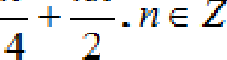
9aHHbIll Bi1]3HHHT B3HT C CilllTa alexlarin.net

1 | 2 | 3 | 4 | 5 | 6 | 7 | 8 | 9 | 10 | 11 | 12
546 | 20 | 3 | 0,441 | -1,5 | 4 | 0 | 40 | 1,5 | 18 | 3 | 2

3gqanne | OTBiZT
 | A) 13 11 9
54 | 188,8
 | 2
17
A) Qa 6) HeT B) l— - ID
24 60

1. 37292-37142=150
12035=420
30.4,2=126
420+126=546
2. 31-11=20
3. + = 2 +1 = 3
4. P=3.0,7.0, 7.(1-0, 7)=0,441

— —11”. ’.3"
— 5' -
3 ”*' — 3"-1 + 2 — —1
— — 1,1.

6. 16=12 +x = x=4
7. 0

8. Vp=4/3.n.R'
V,= S„,.h = nr'.2R= 2nR'=60 nR3= 30

Vp=4/3.n.R'=4/3.30 = 40
OTBeTbi ii peiiieHiie — TpeoxpOBOUHbliï Bapxa T № 199 Alex1arin.net

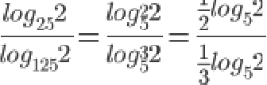
=)—-) = i,s

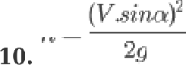

4,X=

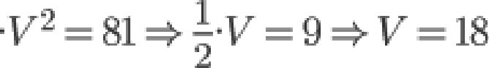
1

4

2.10 20

11. 12.0,75=9

T 7
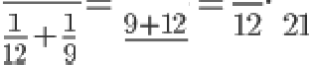
is 12 T 108 =3
108
2 / z)= —3,Tm—in(s+2)

/’(z)= 2z —3,75— 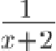
2z —3,75— + = 0
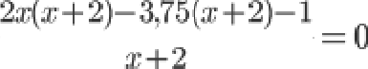
2,2+s‹—3,rs‹—r,s—i=0

Z*#-ü0, z-8,5==0

ç8 2+ ç— A= 0
A = b2 — 4‹sc = 1+ 4.8.34 = 1089 = 33'

z= 16

z == —1 32
16
= — 7,125

16

-7,125

OTBeT: 2

•1acz 2
13.

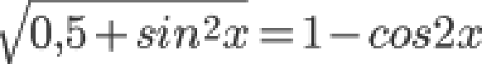
OTBeTbI H petite me — TpeııHpOBOUHbIñ BapHaHT № 199 Alex1arin.net

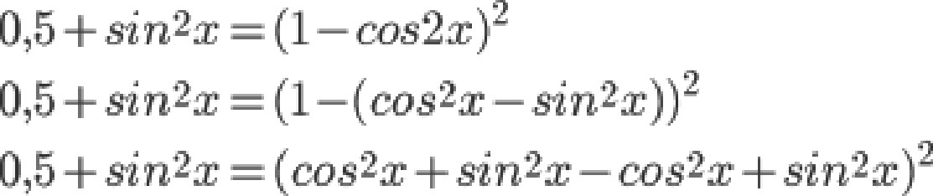

- 4Aa4z+ ńn#z+0,5= 0

A = I›'— 4‹sc = 4 + 32 = 36 = 6'

2 J6

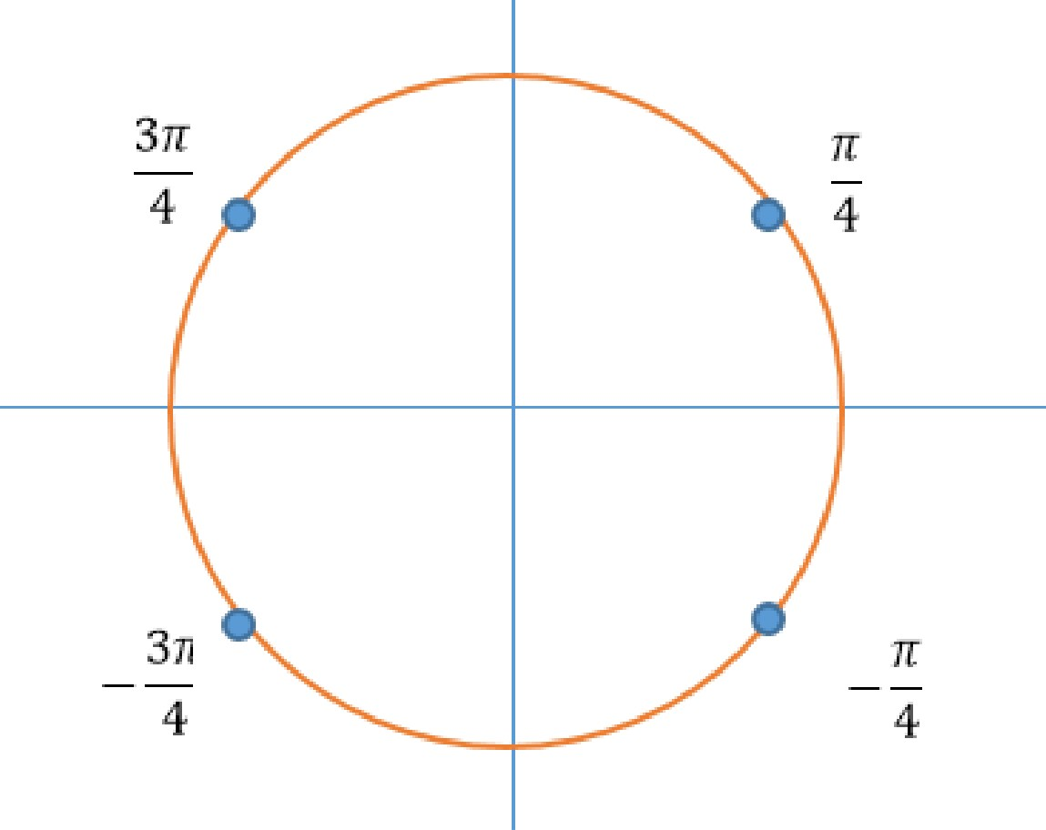
OTBeT: 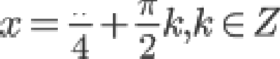
6) [- -•)-; -2 x ]

()TB£lTbI H fl£lIIIF1HH£l — TnO,Hx]3OBO9HbIiï BapxaHT № 199 Alexlarin. net

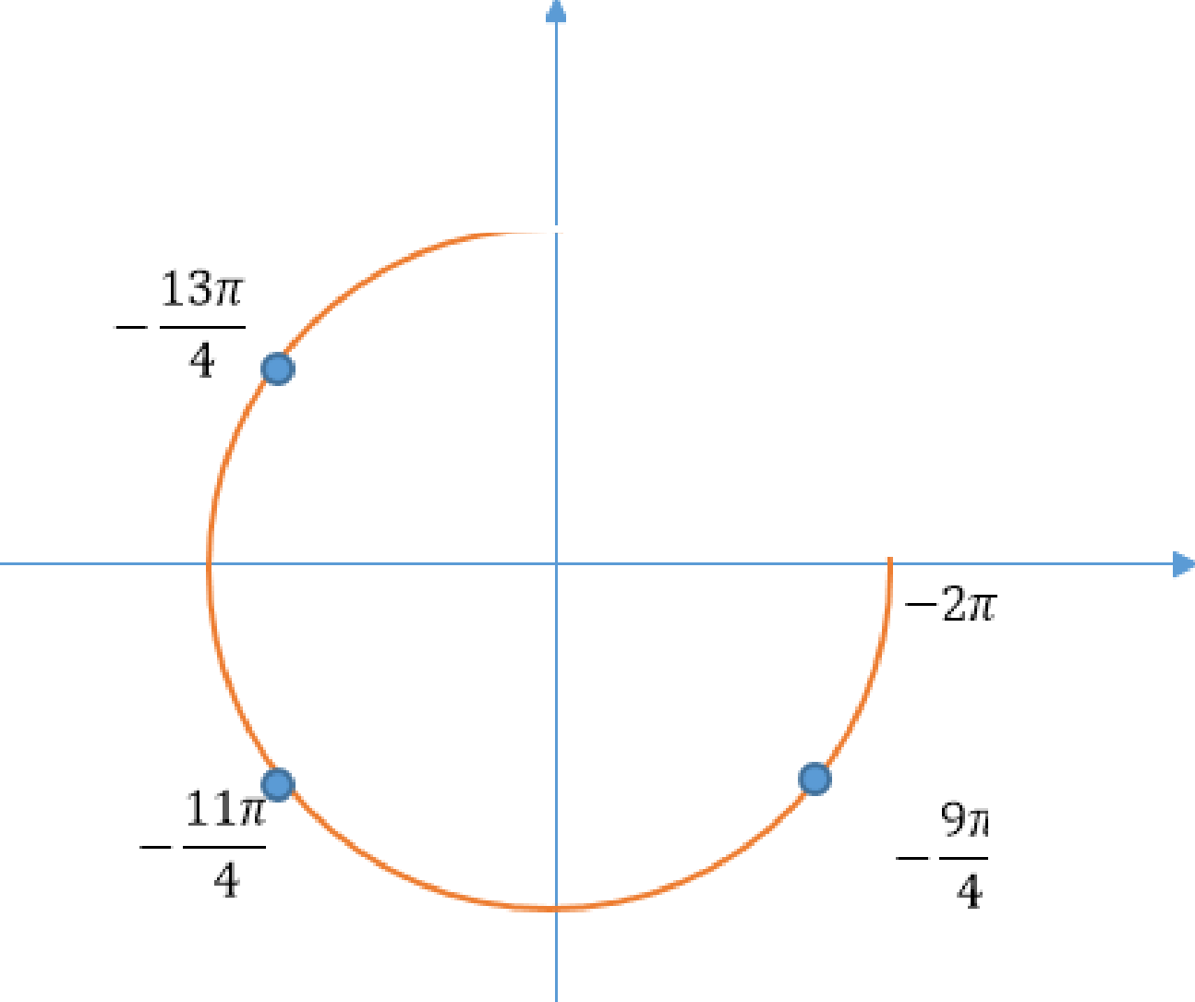
4

